Crowdfix – Sequence Diagram
- Report Submission
A citizen logs in, fills in the problem report form with photos and GPS location, and submits it. The system uploads media to S3, stores the report in the database, and notifies the relevant municipal authority.

Solid arrow = request / call return arrow = response / return value
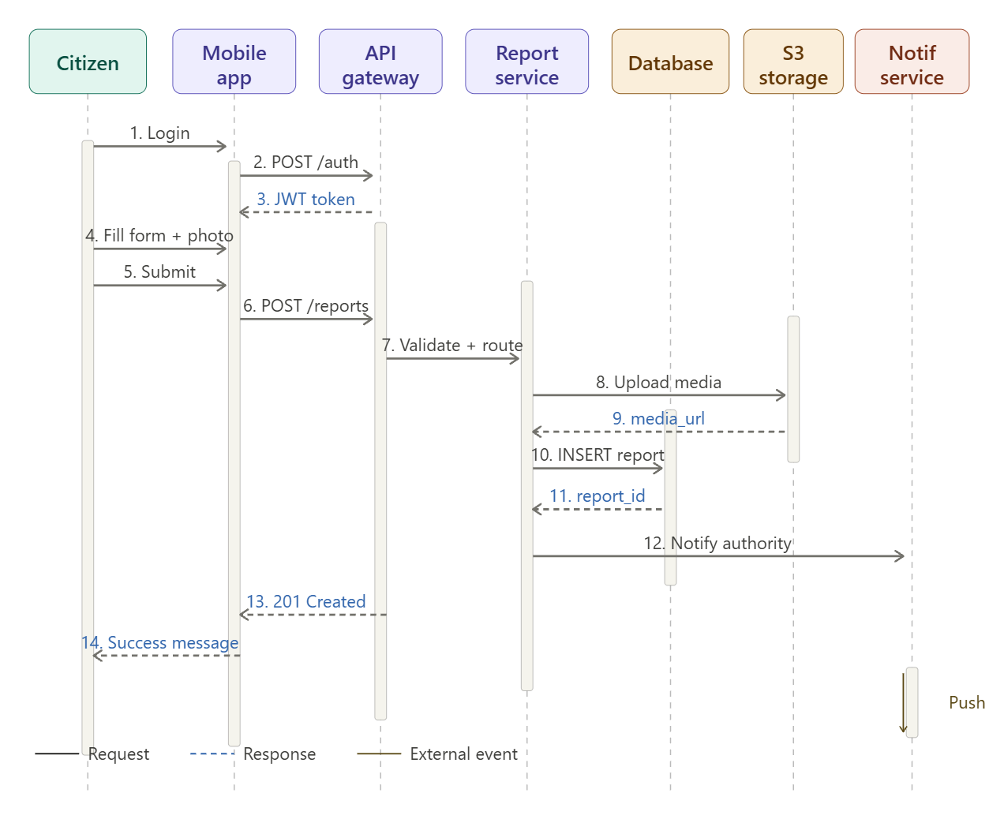

How it works- step by step
When a citizen wants to report a community problem (e.g. a pothole or broken streetlight), the following sequence of events takes place:
Step 1 — Login: The citizen opens the mobile app and logs in. The app sends credentials to the API Gateway.
Step 2 — POST /auth: The API Gateway forwards the credentials to the Report Service for validation.
Step 3 — JWT token (return): On success, a JSON Web Token is issued back to the app. This token acts as a secure session pass and carries the user's identity for all subsequent requests.
Step 4 — Fill form + attach photo: The citizen fills in the report title, category, description, and attaches up to 5 photos. The app also auto-detects the GPS location.
Step 5 — Submit: The citizen taps Submit. The app packages everything and sends it to the API Gateway.
Step 6 — POST /reports: The API Gateway routes the request to the Report Service, which begins processing the submission.
Step 7 — Validate & route: The Report Service validates all required fields (title, category, location) before proceeding.
Step 8 — Upload media: Photos are uploaded directly to S3 cloud storage. This keeps large binary files out of the database.
Step 9 — media_url (return): S3 returns the permanent URL(s) where the photos are now stored.
Step 10 — INSERT report: The Report Service stores the full report record (text fields + photo URLs + coordinates) into the PostgreSQL database.
Step 11 — report_id (return): The database returns a unique report ID, confirming the record was saved successfully.
Step 12 — Notify authority: The Notification Service is triggered to alert the relevant municipal authority that a new report has arrived in their jurisdiction.
Step 13 — 201 Created (return): A success response travels back through the chain to the mobile app.
Step 14 — Success message (return): The app displays a confirmation to the citizen, and the report is now live on the public map.

- Authority Status Update
A municipal authority logs in to the dashboard, views open reports in their jurisdiction, selects one, and updates its status. The system persists the change and dispatches a push/email notification to the original reporter.

Solid arrow = request / call return arrow = response / return value
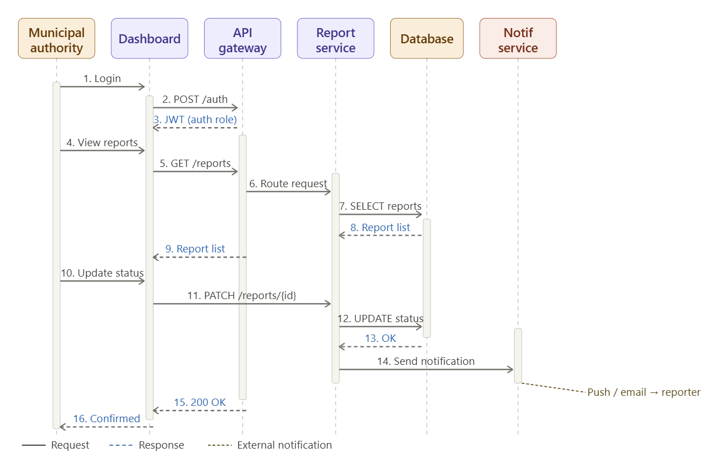
How it works — step by step
When a municipal officer logs into their dashboard and changes the status of a report (e.g. from Open to In Progress), the following sequence takes place:
Step 1 — Login: The authority opens the dashboard and logs in with their credentials.
Step 2 — POST /auth: Credentials are forwarded to the API Gateway for authentication.
Step 3 — JWT (auth role, return): A JWT is returned, this time carrying an authority-level role. This role controls which actions the user is permitted to perform (e.g. updating report status).
Step 4 — View reports: The authority navigates to their report list view.
Step 5 — GET /reports: The dashboard requests all reports assigned to this authority's jurisdiction from the API Gateway.
Step 6 — Route request: The API Gateway forwards the request to the Report Service.
Step 7 — SELECT reports: The Report Service queries the database for all relevant reports.
Step 8 — Report list (return): The database returns the matching records.
Step 9 — Report list (return): The full report list is passed back to the dashboard and displayed to the authority.
Step 10 — Select & update status: The authority selects a specific report and changes its status (e.g. Open → In Progress, or In Progress → Resolved).
Step 11 — PATCH /reports/{id}: The dashboard sends a PATCH request with the new status value and any resolution notes.
Step 12 — UPDATE status: The Report Service writes the status change to the database.
Step 13 — OK (return): The database confirms the update was applied.
Step 14 — Send notification: The Report Service instructs the Notification Service to alert the citizen who originally filed the report.
Step 15 — 200 OK (return): A success response is sent back to the dashboard.
Step 16 — Confirmed (return): The dashboard shows a confirmation to the authority. Simultaneously, the citizen receives a push notification or email informing them of the status

